CO1 ASSESSMENT TOOL 1
CASE STUDY ANALYSIS
Digital Document Management System

Student Name | Laddigam Kesava
Register Number | 192524184
Course Code | CSA10 / CSA1063
Course Title | Software Engineering
Assessment | CO1 Assessment Tool 1 – Case Study Analysis

Problem Statement
Develop a secure platform for organizations to upload, categorize, search, share, version, and manage access to important documents.

1. Understand the Problem Statement
The proposed Digital Document Management System (DDMS) is a secure, centralized software platform for managing organizational documents throughout their lifecycle. It replaces scattered paper files, local folders, email attachments, and uncontrolled file copies with a structured repository in which documents can be uploaded, categorized, searched, shared, versioned, and accessed according to user permissions.
The system is intended to improve document availability, security, traceability, collaboration, and operational efficiency while reducing duplication, accidental deletion, unauthorized access, and difficulty in locating the latest version of a document.
1.1 Objectives
- Provide a centralized repository for organizational documents.
- Allow users to upload documents with metadata such as title, category, department, owner, and date.
- Enable fast search and filtering using keywords, categories, dates, and document attributes.
- Control document access using role-based permissions.
- Maintain version history so users can identify and restore earlier versions.
- Support secure sharing and controlled collaboration.
- Maintain audit logs for important document activities.
- Provide backup and recovery mechanisms to improve reliability.
1.2 Scope
In Scope | Out of Scope | Target Users
Upload, storage, categorization, search, sharing, version control, access control, audit logs, backup. | Editing the internal business content of every file; advanced enterprise records management beyond the proposed platform. | Administrators, employees, managers, document owners, auditors.
Web-based access and notifications. | Physical document scanning hardware integration as a mandatory component. | Organizations and departments handling important digital documents.

2. Identify Key Stakeholders and Challenges
Stakeholder | Role / Responsibility | Main Need | Major Challenge
System Administrator | Creates users/roles, manages permissions, backups and system configuration. | Central control and security. | Misconfiguration, account management and monitoring.
Employees / End Users | Upload, search, view, download and share permitted documents. | Easy and quick access. | Finding correct files and avoiding duplicate copies.
Managers / Document Owners | Approve access and manage important departmental documents. | Controlled sharing and visibility. | Maintaining correct versions and approvals.
Security / Auditor | Reviews access and activity logs. | Traceability and compliance. | Detecting unauthorized activity.
Organization / Management | Defines policies and expects reliable document operations. | Security, availability and productivity. | Cost, adoption and governance.
Development / Maintenance Team | Builds, tests, deploys and maintains the system. | Clear requirements and maintainable architecture. | Integration, scalability and defect management.
2.1 Key Challenges
- Unauthorized access to confidential documents.
- Multiple copies of the same document causing confusion.
- Difficulty locating documents stored in different folders or email threads.
- Accidental deletion or loss of important files.
- Lack of clear version history and difficulty identifying the latest version.
- Uncontrolled sharing through email or external storage.
- Poor auditability because manual processes do not capture every activity.
- Growth in document volume leading to storage and performance challenges.

3. Analyze the Current Approach
In a typical current approach, employees store files on individual computers, shared folders, local servers, email attachments, or cloud drives. Documents may be named differently by different users and copies can be created whenever a file is edited or shared. Access is often managed manually, and there may be limited visibility into who viewed, changed, downloaded, or shared a document.
3.1 Existing System – Strengths and Limitations
Aspect | Strength | Limitation / Gap
Local folders / shared drives | Simple and familiar. | Hard to organize at scale; inconsistent naming and permissions.
Email sharing | Fast for small exchanges. | Creates duplicate attachments and uncontrolled copies.
Manual versioning | Users can save multiple copies. | No reliable version chain; latest version may be unclear.
Basic access control | Some folders can be restricted. | Permissions may be too broad or inconsistently applied.
Manual backup | Possible to copy important files. | Recovery may be slow or incomplete.
Traditional paper records | Useful where physical signatures are required. | Slow search, physical storage, loss/damage risk.
3.2 Major Gaps Identified
- Centralized and structured document repository is missing.
- Search is not standardized across all documents.
- Version control is weak or manual.
- Role-based access is not consistently enforced.
- Audit trails are incomplete.
- Document sharing is difficult to control.
- Backup and recovery are not integrated with daily document operations.

4. Proposed Software Solution Using Software Engineering Principles
The proposed DDMS will use a modular web-based architecture. Users authenticate through a secure login service and interact with document functions through a web interface. Application services handle upload, metadata, search, sharing, versioning, permissions and auditing. A document repository stores files while a database stores metadata, user roles, permissions, version information and audit records.
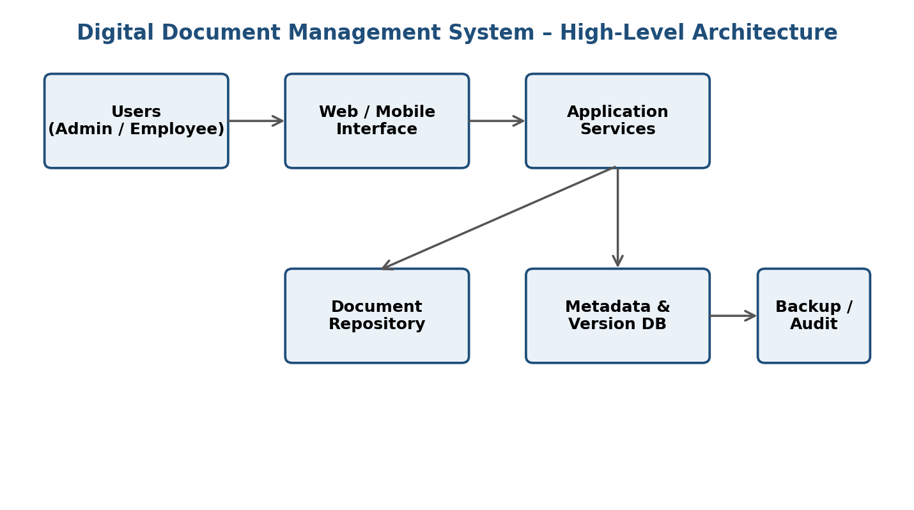
Figure 1. High-level architecture of the proposed Digital Document Management System.
4.1 Major Functional Modules
Module | Key Functions | Expected Result
User & Role Management | Registration, login, roles, permissions, account control. | Only authorized users access permitted functions.
Document Management | Upload, download, preview, metadata, categorization. | Organized centralized document repository.
Search & Filter | Keyword search, category, date, owner and metadata filters. | Fast retrieval of required documents.
Version Control | Create versions, compare metadata, restore previous versions. | Clear document history and latest-version identification.
Sharing & Collaboration | Controlled sharing, access duration, permissions. | Secure collaboration without uncontrolled copies.
Audit & Activity Logs | Track upload, download, update, share and access events. | Traceability and accountability.
Backup & Recovery | Scheduled backups and restoration procedures. | Improved availability and reduced data-loss risk.
Notifications | Alerts for sharing, updates, approvals or important actions. | Better awareness and timely action.
4.2 Functional Requirements
- The system shall authenticate users before granting access.
- The system shall allow authorized users to upload documents and metadata.
- The system shall categorize documents using predefined categories.
- The system shall allow users to search and filter documents.
- The system shall maintain version history for modified documents.
- The system shall allow administrators to assign roles and permissions.
- The system shall support controlled document sharing.
- The system shall record significant user and document activities.
- The system shall support backup and restoration.
4.3 Non-Functional Requirements
Requirement | Implementation Consideration
Security | Authentication, authorization, encryption, secure sessions and audit logging.
Scalability | Modular services and scalable storage/database design.
Reliability | Backups, recovery and validation of uploaded documents.
Usability | Simple dashboard, clear navigation and powerful search.
Maintainability | Separation of modules, clean interfaces and documentation.
Performance | Indexed metadata search and optimized document retrieval.
Availability | Reliable hosting, backup and recovery procedures.
Privacy | Access restrictions and controlled sharing of sensitive documents.
4.4 Software Engineering Principles Applied
- Modularity: User management, documents, search, sharing, versioning and auditing are separated into manageable modules.
- Scalability: Storage and application components can be expanded as document volume and users increase.
- Maintainability: Clear module boundaries and documented interfaces simplify updates and bug fixing.
- Reliability: Validation, backup, recovery and version history reduce data-loss risk.
- Usability: The interface is designed around common tasks such as upload, search, view and share.

- Security: Role-based access, authentication, controlled sharing and audit trails protect documents.
- Testability: Each module can be unit tested and integrated before system-level testing.
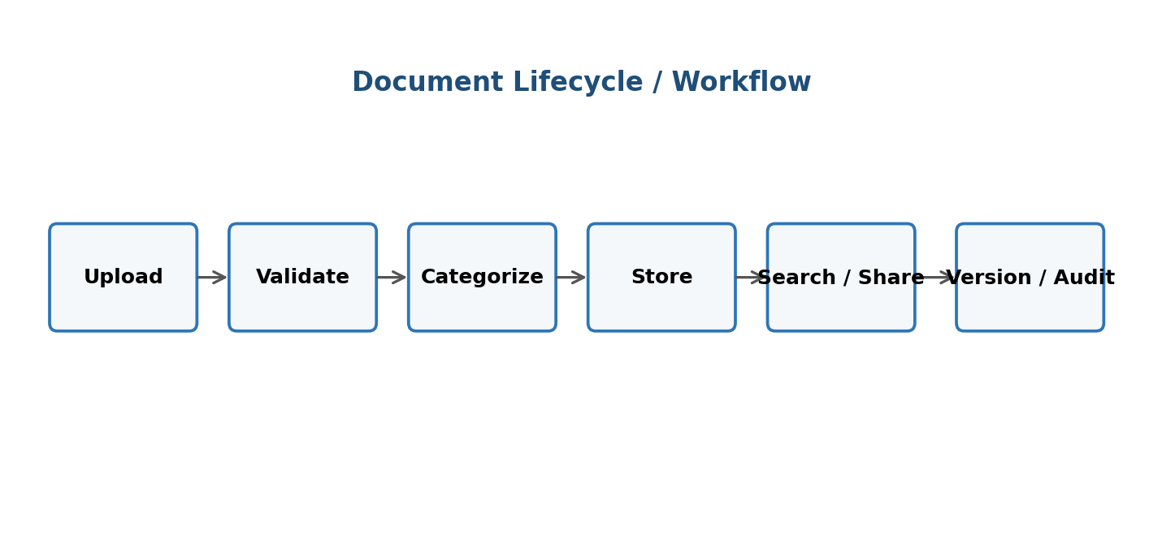
Figure 2. Proposed document lifecycle and workflow.

5. Justify the Chosen Methodology / Framework
Agile Scrum is selected as the most suitable development framework for the Digital Document Management System. The system contains multiple independent modules and user needs may evolve after stakeholders see working features. Scrum supports incremental delivery, frequent feedback, continuous testing and prioritization of the highest-value features.
5.1 Why Agile Scrum is Suitable
Scrum Element | Application to DDMS
Product Backlog | Maintain prioritized requirements such as login, upload, search, versioning, sharing and audit.
Sprint Planning | Select a manageable set of features for each sprint.
Incremental Development | Deliver working modules instead of waiting for the complete system.
Sprint Review | Demonstrate completed features to stakeholders and collect feedback.
Retrospective | Identify process problems and improve the next sprint.
Continuous Testing | Test security, permissions, search, upload and versioning during development.
Continuous Improvement | Update priorities as organizational needs and feedback change.
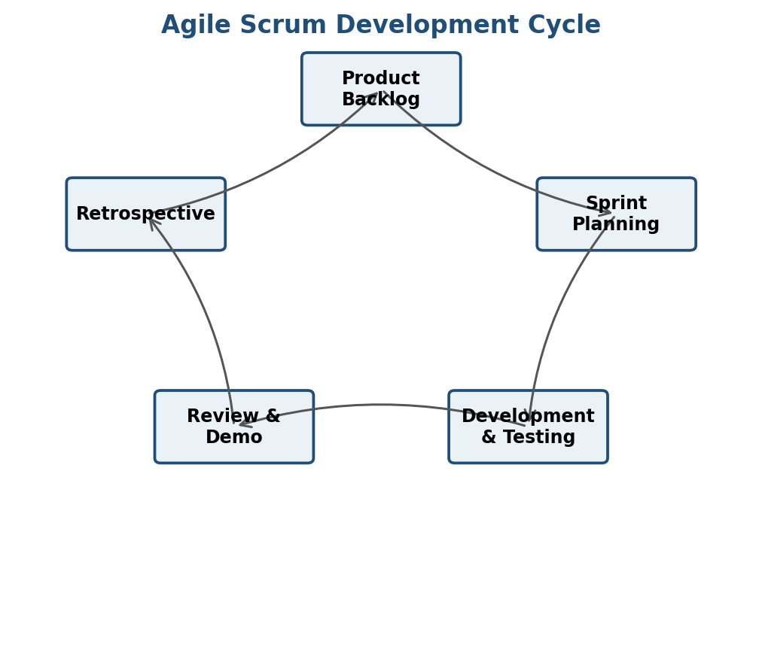
Figure 3. Agile Scrum cycle for iterative development of the proposed system.
5.2 Proposed Sprint Plan
Sprint | Major Work | Deliverable | Validation
Sprint 1 | Requirements, UI prototype, authentication and roles. | Login + role management. | Authentication and access tests.
Sprint 2 | Upload, metadata and repository. | Document upload and organization. | File validation and storage tests.
Sprint 3 | Search, filter and document viewing. | Searchable document catalogue. | Search/performance tests.
Sprint 4 | Version control and sharing. | Version history + controlled sharing. | Permission/version tests.
Sprint 5 | Audit logs, backup and notifications. | Monitoring and recovery features. | Security, backup and integration tests.
Sprint 6 | System hardening and final improvements. | Release candidate. | User acceptance and final regression testing.

6. Discuss Expected Outcomes and Limitations
6.1 Expected Outcomes / Benefits
- Faster retrieval of important documents through centralized search.
- Reduced duplication and confusion through version control.
- Improved confidentiality through role-based access.
- Better accountability through audit logs.
- Safer collaboration through controlled sharing.
- Reduced risk of document loss through backup and recovery.
- Improved productivity because users spend less time searching for files.
- Better organizational control over document lifecycle and ownership.
6.2 How the Solution Addresses Identified Challenges
Identified Challenge | Proposed Feature | Result
Unauthorized access | Role-based access control + authentication | Only permitted users can access documents.
Duplicate / outdated files | Version control | Latest version is identifiable and earlier versions are retained.
Difficult search | Metadata + keyword search | Documents can be found quickly.
Uncontrolled sharing | Permission-based sharing | Sharing is controlled and traceable.
Data loss | Backup and recovery | Documents can be restored after failures.
Poor traceability | Audit logs | Important actions can be reviewed.
Growing volume | Scalable storage and modular design | System can grow with organizational needs.
6.3 Risks and Implementation Challenges
- Migration of existing documents may be time-consuming.
- Incorrect permissions can expose confidential documents.
- Large files may affect storage and performance.
- Users may resist changing from familiar folder/email practices.
- Integration with existing organizational systems may require additional development.
- Backup and disaster recovery require regular testing, not just configuration.
- Security vulnerabilities must be continuously monitored and addressed.

6.4 Limitations
- The proposed case study focuses on core document management and does not define every enterprise records-management requirement.
- Advanced OCR, digital signatures, AI-based classification and complex compliance workflows are not mandatory in the initial version.
- System performance depends on infrastructure, storage capacity and network conditions.
- Successful adoption depends on user training and correct organizational policies.
6.5 Future Enhancements
- AI-assisted document classification and semantic search.
- Optical Character Recognition (OCR) for scanned documents.
- Digital signatures and approval workflows.
- Mobile application for secure document access.
- Integration with enterprise identity providers and productivity suites.
- Advanced analytics and dashboards for document usage.
- Automated retention policies and compliance reporting.

Appendix A – Assessment Rubric Alignment
The case study has been organized to directly address the six areas in the provided CO1 Assessment Tool 1 rubric: problem understanding, stakeholder and challenge analysis, current system analysis, proposed software solution and software engineering principles, methodology/framework justification, and outcomes/limitations/future enhancements. The supplied assessment sheet assigns a total of 25 marks and gives the highest performance level to clear, complete and technically justified analysis. fileciteturn0file0L53-L58
Rubric Criterion | Where Addressed in Report | Focus for Excellent Performance
Problem Understanding (30%) | Section 1 | Clear problem, objectives and scope.
Stakeholder & Challenge Analysis (25%) | Section 2 | Stakeholders, roles and challenges are analyzed.
Current System Analysis (20%) | Section 3 | Strengths, limitations and gaps are identified.
Proposed Software Solution & Principles (15%) | Section 4 | Feasible solution with modularity, scalability, maintainability, reliability, usability and security.
Methodology / Framework Justification (10%) | Section 5 | Agile Scrum is selected and technically justified.
Expected Outcomes / Limitations | Section 6 | Benefits, risks, limitations and future enhancements are included.
Conclusion
The proposed Digital Document Management System provides a secure and structured approach to organizational document handling. By combining centralized storage, categorization, search, role-based access, version control, controlled sharing, audit logging and backup, the system addresses the major limitations of manual and fragmented document management. Agile Scrum is appropriate because the system can be delivered incrementally, validated frequently, and improved through stakeholder feedback. The design emphasizes security, usability, scalability, reliability and maintainability, making it suitable as a practical software engineering solution.

